IOT BASED AGRICULTURE FIELD MONITORING SYSTEM
AIM:
The main aim of this project is to design low cost automated agriculture System Using an IOT.

PURPOSE:
The purpose of this project is to webpage based automation system for agriculture to reduce the manual monitoring of the field and get the information in the form of GPRS.
TRANSMITTER SECTION:

MICRO
CONTROLLER
LCD DISPLAY
(16*2 LINES)
POWERSUPPLY

TEMPERATURE
SENSOR

GPRS
SOIL SENSOR

RELAY
WATER LEVEL SENSOR

PUMP MOTOR

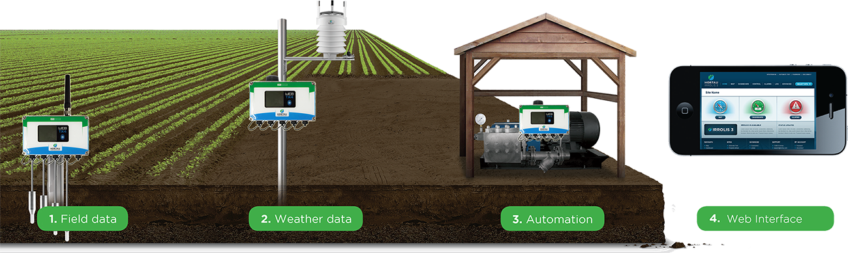
DESCRIPTION:
In this paper, the development of the automated agriculture system based on microcontrollers at experimental scale within rural areas is presented. The aim of the implementation was to demonstrate that the automatic irrigation can be used to reduce water use. A microcontroller for data acquisition, and transceiver; the sensor measurements are transmitted to a microcontroller. This gateway permits the automated activation of irrigation when the threshold values of soil moisture and temperature is reached.
This receiver unit also has a duplex communication link based on a cellular Internet interface, using General Packet Radio Service (GPRS) protocol, The Internet connection allows the data inspection in real time on a website, where the soil-moisture and temperature levels are displayed through an application interface and stored in a database server. This access also enables direct programming of scheduled agriculture schemes and trigger values in the receiver according the crop growth and season management. Because of its energy autonomy and low cost, the system has potential use for organic crops, which are mainly located in geographically isolated areas where the energy grid is far away.
HARDWARE USED:
- Micro Controller
- Power supply
- GSM/GPRS modem
- Temperature sensor
- Water level sensor
- Soil sensor
SOFTWARE USED:
- Keil IDE
- Embedded C
- Express PCB
- Flash Magic/ISP

RESULT:
By using this project we can implement wireless based embedded system for Irrigation.

